University Staff Council Meeting Agenda

Tuesday, November 19, 2024

9:45 - 10:45am

General Services Complex 101 B/C

# I. Welcome

# II. Call to Order - Vice-Chair Katie St. Clair

## Motion: Michelle Brown-Link

## Second: Cindy McCasland

* Mission: The University Staff Council (USC) cultivates a collaborative work environment for Texas A&M staff under the Office of the President through quality representation, impactful service, innovative programs and open workplace communications.
* Vision: Staff feel supported, included and valued in this environment where we practice respect, excellence, leadership, loyalty, integrity and selfless service.

# III. Roll Call of Members - Secretary, Clint Patterson

# VI. Approval of Minutes - October 2024

# VII. Treasurer’s Report - Tracey Posey

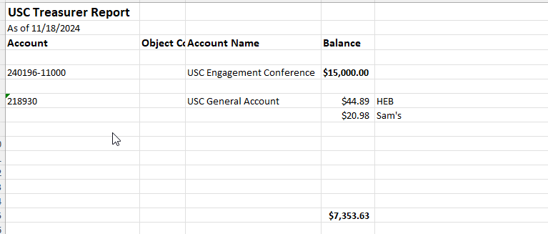

# VIII. Update from Meeting with Interim Vice President of Human Resources - Katie St. Clair

Discussed recurring themes related to FLSA within the organization, such as pay equity, exempt v. non-exempt, overtime

Recommendation is to clarify and develop consistent messaging

# IX. USC Staff Inquiries - Katie St. Clair

Resolved: Recommended to utilize local flu clinics

New: concern(s) about healthcare data showing inside WebMD; potential for staff to opt out?

New: Doctoral Tuition Assistance - planned review by TAMUS; apply by May 31, 2025

# X. USC Internal Committee updates

## 1. Branch Campus Committee

-Wesley Swanson

-Galveston Halloween costume stress relief event

-VetMed Halloween celebration; upcoming staff awards; design for new animal hospital

-Law School - topping out ceremony

-Dentistry - new staff awards; raised $3000 for charitable campaign

Action:

Consider a North Texas gathering, similar to South Texas TAMU campus communities

## 2. Communications and Outreach Committee

-Chelsey Cooke

-TAMU @ work email (bi-weekly communication with TAMU staff; no more USC newsletter)

-USC meetings on LiveWhale calendar

-Use of digital signage in campus buildings

Action

Update Spring 2025 USC meetings in LiveWhale

## 3. Community Engagement and Respect in the Workplace (CERW)

-Noeline Gunasekara

-revamp staff appreciation event and narrative

-overlap/collaboration with SEF and PD committees, as well as new Director of Staff Advocacy and Support position

-CEHD Townhall Meeting on November 20

## 3. Elections Committee

-Mark Gleason

-special elections for officers - nomination due November 19th by 5:00pm

-fill vacancy in Division of Finance

-Bi-laws - up to 10 ex-officio positions

## 5. Professional Development Committee (PD)

-Michele Brown-Link

-Committee met November 11

-Mentorship Program for USC pilot in 2025

-Employee Learning Week update - all sections filled in BCS

-Action

-Request for Common Grounds speakers/topics

-Book club interest form link

## 6. Staff Emergency Fund Committee (SEF)

-Ashley Winterrowd

-Committee perceives an increase in number of applications

-Increase awareness in how to contribute/donate to SEF

-Action

Update USC website with SEF committee members & new/updated SEF application

## 7. Work Life and Benefits Committee (WLB)

-Rebecca Luckey

-No report; did not meet in November

# XI. External Committee Appointments

## System Employment Benefits Advisory Committee - Rebecca Luckey

-#1 complaint is delta dental

-TAMUS reviewing dental insurance; delta dental remains best option

-Committee met late October

## Transportation Services Advisory Committee - Lt. Jennifer Enloe

-Bush/Wellborn - bwx-bcs.org

-consideration for electric/micro-mobility ($10 fee)

## Dining Services Committee - Tracey Posey

-no update

## TAMU IT Governance Program - Jeff Lowry

-no update

## Strategic Budget Council - Katie St. Clair/Tracey Posey

-~40 Strategic Budget Council meetings this season

-shared current schedule on USC Google Drive

## Business Services Advisory Council - Katie St. Clair

-No report

## Jed program Steering Committee - Melissa Bohnsack

-no report; meeting November 25

## Sesquicentennial Executive Committee - Catherine Halverson

-Officially added to Committee

-Clint Patterson will share previous committee meeting notes

## University Sustainability Advisory Committee - Sean Cargo

-meeting monthly

-discussed reporting matrix; anticipate institutional scores falling

1. AI Steering Committee - Daniel Roberts

-no report

# XII. Additional Reports

## Employee Learning Week 2024 update

# 2024-2025 Goals:

**Enhance Communication Channels and Serve as a Liaison**  
Strengthen internal communication by serving as a liaison between staff and university administration. This includes implementing regular updates, gathering staff feedback, and addressing concerns to promote transparency and ensure that staff voices are heard.

**Increase Visibility and Awareness of University Programs and Staff Council**  
Boost the visibility of the University Staff Council, its representatives, and university programs by developing targeted awareness campaigns. Highlight professional development opportunities and foster greater engagement among staff members.

**Foster Staff Well-being and Professional Development**  
Focus on improving staff well-being, retention, and compensation by advocating for pay equity, cost-of-living adjustments, and organizing professional development programs. Support staff growth through workshops, training sessions, and initiatives that enhance career advancement.

# XIII. Adjournment

**Motion: Cindy McCasland**

**Second: Michelle Brown-Link**

**Next meeting:** **December 17, 2024, in GSC from 2:30-3:30pm**

**No Common Grounds presentation/event.**